User Manual
Convert scans, photos and PDFs into editable Word, Excel and HTML documents
Product | Falcon OCR 1.0
Document ID | FOCR-UM-001
Version | 1.2
Date | 2026-09-24
Status | Released for review
Prepared by | Falcon OCR Development Team
This manual explains how to install, activate and use Falcon OCR 1.0. No technical knowledge is required.
Document control
Version | Date | Author | Changes
0.9 | 2026-09-20 | Falcon OCR Development Team | Draft for internal review.
1.0 | 2026-09-24 | Falcon OCR Development Team | Released with Falcon OCR 1.0: OCR engine, layout reconstruction, exports, trial and licensing.
1.1 | 2026-09-24 | Falcon OCR Development Team | UI extensions: font and size combo boxes, English/Chinese/Japanese interface (gettext PO), collapsible sidebar, resizable settings panel, trial notification below the toolbar.
1.2 | 2026-09-24 | Falcon OCR Development Team | New application icon; OCR model information removed from Settings; default font setting; collapsible Files / Thumbnails panel.
Contents
1. Welcome to Falcon OCR 3
1.1 What you can do 3
1.2 How it works — in four steps 4
2. Installation 4
2.1 System requirements 4
2.2 Installing 4
2.3 Uninstalling 5
3. Trial and activation 6
3.1 The 7-day trial 6
3.2 Getting a license key 7
3.3 Entering the key 7
3.4 License messages 7
4. The main window 9
4.1 Customizing the window 10
5. Adding documents 11
5.1 Files and PDFs 11
5.2 Image sequences 11
5.3 Clipboard, scanner, drag and drop 11
5.4 Managing documents 11
6. Preparing pages 12
7. Choosing the settings 13
7.1 OCR Settings 13
7.2 Output Format 13
7.3 Advanced Settings 13
8. Recognizing 14
9. Checking and correcting the result 15
9.1 Side-by-side view 15
9.2 Finding and correcting text 15
9.3 Changing formatting 15
9.4 Original Image view 16
10. Exporting 17
10.1 What the exports look like 17
11. Quick OCR 20
12. Batch processing 20
13. History 21
14. Settings 21
15. Command line 23
16. Keyboard shortcuts 23
17. Tips for best results 24
18. Troubleshooting 25
19. Privacy and data 25
Appendix A. Glossary 26

1. Welcome to Falcon OCR
Falcon OCR turns scanned documents, photos of pages, image files and PDF files into documents you can edit. It reads the text (optical character recognition, OCR) and rebuilds the page as it was — headings, paragraphs, columns, bulleted lists, tables, pictures, font sizes, bold text and colors — and saves the result as a Word document, an Excel workbook or a web page.

1.1 What you can do
- Open PDF files, single images (PNG, JPG, BMP, GIF, TIFF …), multi-page TIFFs and image sequences (several images that form one document).
- Add pages from the clipboard or a scanner, or simply drag files into the window.
- Rotate and crop pages before recognition.
- Recognize text in English, Chinese, Japanese, Korean and Russian — completely offline; your documents never leave your computer.
- Check the result side by side with the original, correct words and change paragraph styles.
- Export to Microsoft Word (.docx), Microsoft Excel (.xlsx) or HTML — as an editable document or as an exact copy of the page.
- Convert many files at once with Batch Process, or grab text quickly with Quick OCR.

1.2 How it works — in four steps
Table 1 – Workflow
Step | What you do | Where
1. Add | Add a PDF, images or a scan. | Toolbar: Add Files, Scan, From Clipboard
2. Set | Choose the language, document type and output format. | Right-hand panel
3. Recognize | Click Recognize and check the result next to the original. | Toolbar: Recognize (F5)
4. Export | Click Export — the document opens in Word, Excel or your browser. | Export button (Ctrl+E)

2. Installation

2.1 System requirements
Table 2 – System requirements
Item | Requirement
Operating system | Windows 10 or Windows 11, 64-bit
.NET Framework | 4.7 or later (already part of Windows 10 version 1703 and later, and of Windows 11)
Memory | 4 GB RAM (8 GB recommended for large PDFs)
Disk | 200 MB for the application, plus space for your documents
Optional | Microsoft Word / Excel (or compatible software) to open exported files; a WIA-compatible scanner
Internet | Not required — Falcon OCR works completely offline

2.2 Installing
- Copy the Falcon OCR folder (supplied by your vendor or administrator) to a location of your choice, for example C:\Program Files\Falcon OCR or your Documents folder.
- Open the folder and double-click FalconOcr.exe. Tip: right-click it and choose Send to → Desktop (create shortcut).
- No installer and no administrator rights are needed. Keep all files of the folder together — the models folder and the DLL files are required.

2.3 Uninstalling
Delete the Falcon OCR folder. To remove your settings, history and license as well, delete the folder %LOCALAPPDATA%\FalconOCR (type it in the Explorer address bar).

3. Trial and activation

3.1 The 7-day trial
When you start Falcon OCR for the first time without a license, a free 7-day trial begins. All features are available during the trial.
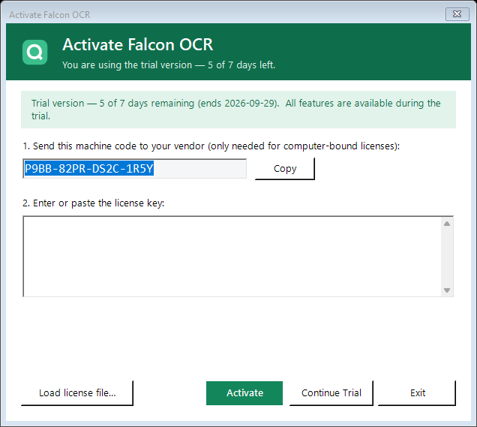
Figure 1 – Activation window during the trial
- At every start the activation window shows how many days are left.
- Click Continue Trial to use Falcon OCR, Activate to enter a license key, or Exit.
- While you are using the trial, the title bar shows an amber badge TRIAL · n days left — Activate now, and a notification below the toolbar shows the remaining days. Click the badge or Activate now at any time to activate; ✕ hides the notification until the next start.
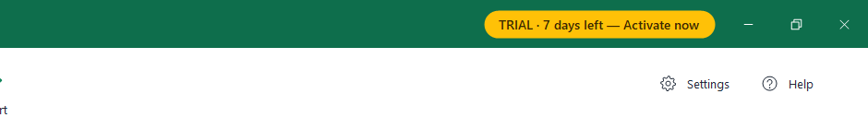
Figure 2 – Trial badge in the title bar
Figure 3 – Trial notification below the toolbar
When the 7 days are over, Falcon OCR cannot be used until you enter a license key:
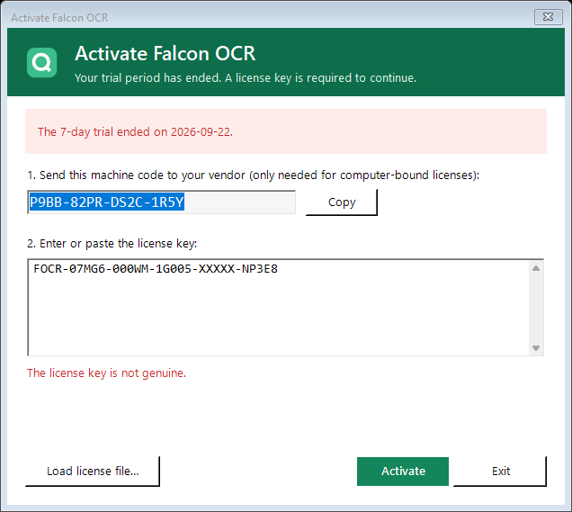
Figure 4 – Activation window after the trial
Note: Changing the computer's date or deleting program data does not extend the trial — it ends the trial immediately.

3.2 Getting a license key
- Purchase a license from your vendor.
- If your license is bound to one computer, the vendor needs your machine code. It is shown in the activation window (and in Settings → License). Click Copy next to it and send it to your vendor by e-mail.
- You receive a license key (a long text that starts with FOCR-) or a license file (.lic).

3.3 Entering the key
- Open the activation window: at start-up, by clicking the trial badge, or via Settings → License → Change license key….
- Paste the key into the box (Ctrl+V) — line breaks and spaces do not matter — or click Load license file… and select the .lic file.
- Click Activate. A confirmation shows the licensee and the validity, e.g. Licensed to ACME Ltd · serial 1001 · perpetual · this computer only.

3.4 License messages
Table 3 – License messages
Message | Meaning and what to do
The license key is not in a valid format. | The key was not copied completely. Copy the whole key again or use the .lic file.
The license key is not genuine. | The key was changed or is not from your vendor. Request a new key.
This license key was issued for a different computer. | The key is bound to another machine code. Send your machine code to the vendor.
The license expired on … | Your time-limited license has ended. Ask your vendor for a renewal.
The system clock is set earlier than the last use… | Correct the date and time of your computer.
Tip: Administrators can deploy a license for all users by placing a file named license.key (containing the key) next to FalconOcr.exe or in C:\ProgramData\FalconOCR.

4. The main window
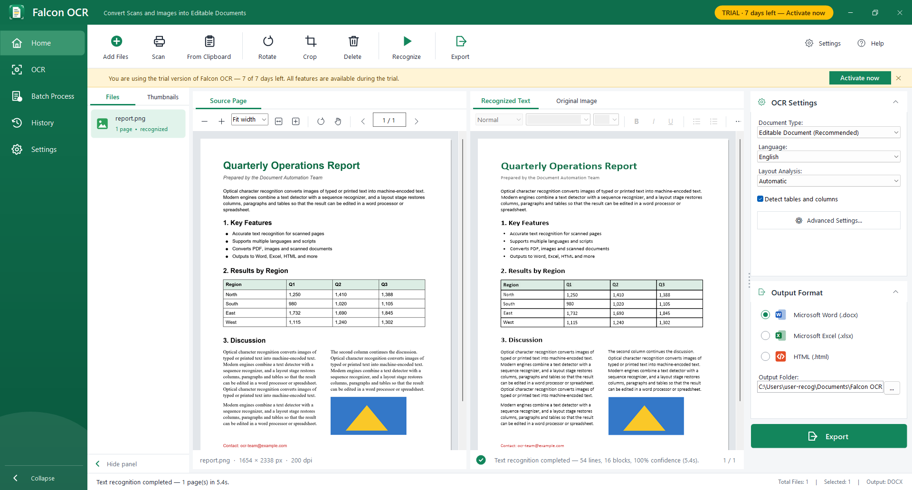
Figure 5 – Main window after recognition
Table 4 – Main window areas
Area | Purpose
Title bar | Product name, trial badge, minimise / maximise / close. Drag it to move the window; double-click to maximise.
Trial notification | Only in the trial: remaining days, Activate now, ✕ to hide.
Navigation bar (left) | Home (workspace), OCR (quick text), Batch Process, History, Settings; « Collapse at the bottom.
Toolbar | Add Files, Scan, From Clipboard, Rotate, Crop, Delete, Recognize, Export; Settings and Help on the right.
Files / Thumbnails | Your documents; the pages of the selected document; « Hide panel at the bottom.
Source Page | The original page with zoom and page controls.
Recognized Text / Original Image | The recognized page rebuilt next to the original / the original with the detected areas.
OCR Settings / Output Format | Language, document type, layout options, output format and folder; Export button. Drag its left edge to change the width.
Status bar | Progress and messages; number of files, selection and output format.

4.1 Customizing the window
- Interface language — English, 简体中文 (Chinese) or 日本語 (Japanese): Settings → General → Interface language, then Save and confirm the restart. On first start Falcon OCR uses the language of Windows.
- Collapse the sidebar — click « Collapse at the bottom of the navigation bar to show only the icons (point at an icon to see its name). Click » to expand it again.
- Hide the Files / Thumbnails panel — click « Hide panel at the bottom of the panel to get more room for the pages; a narrow strip remains. Click » on the strip to show the panel again.
- Resize the settings panel — drag the dotted grip at the left edge of the right-hand panel with the mouse (280–640 pixels).
- Falcon OCR remembers these choices, the window size and position.
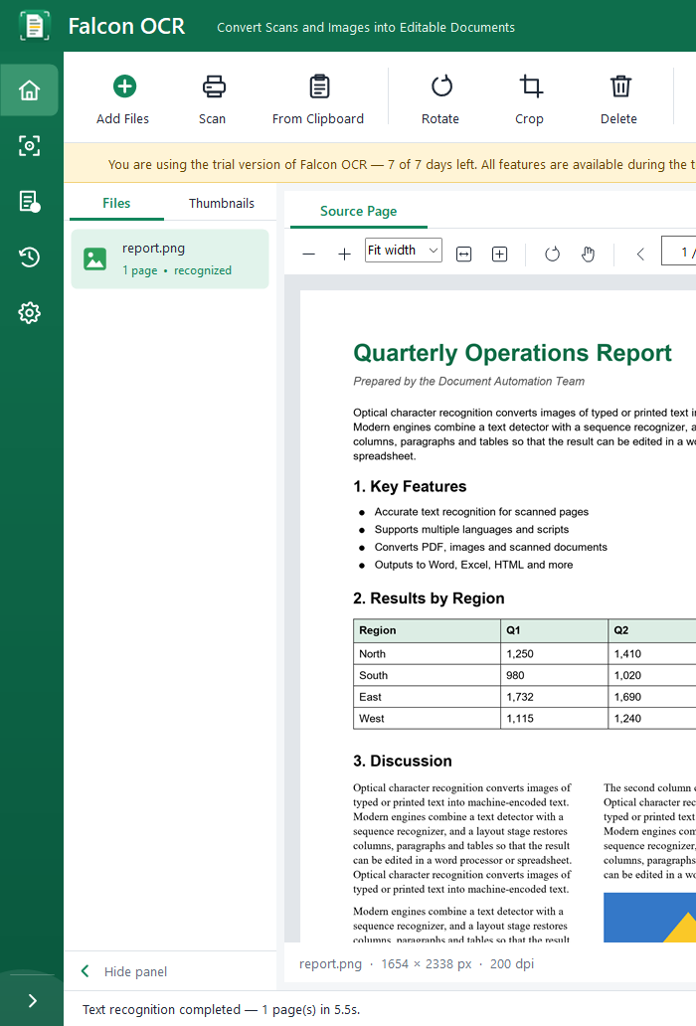  Figure 6 – Collapsed sidebar | 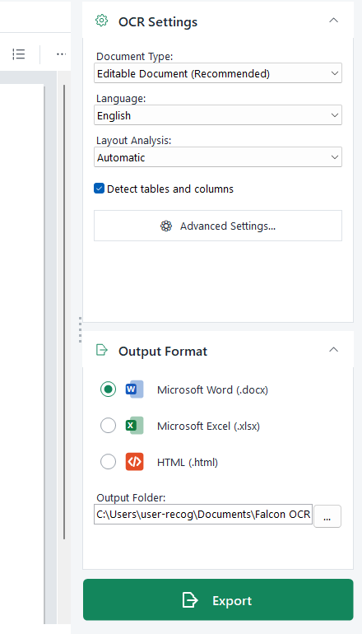  Figure 7 – Grip for resizing the settings panel
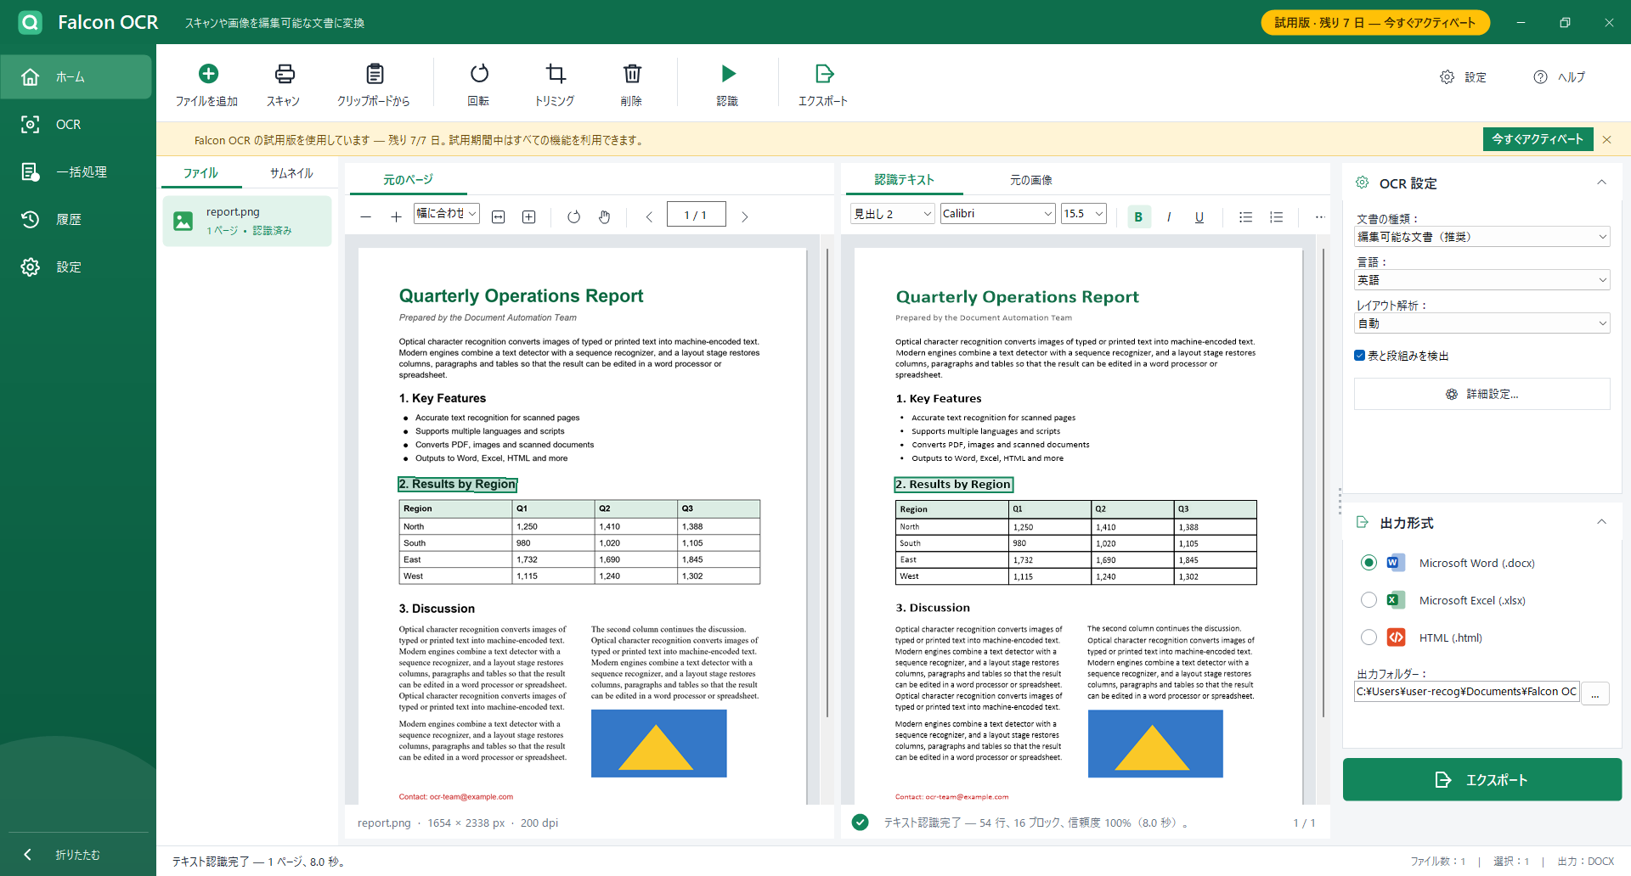
Figure 8 – The workspace with the Japanese interface

5. Adding documents

5.1 Files and PDFs
- Click Add Files and choose Add files (PDF, images)… (or press Ctrl+O).
- Select one or more files. Each file becomes a document in the Files list. A PDF shows its page count, e.g. 12 pages.
Supported: PDF; PNG, JPG/JPEG, BMP, GIF, TIFF (also multi-page), ICO, EMF, WMF. Photos taken with a phone are turned upright automatically.

5.2 Image sequences
A book or a long letter is often scanned as one image per page. Combine them into one document:
- Add Files → Add images as one document (image sequence)… and select all page images, or
- Add Files → Add folder as image sequence… and select the folder.
- Pages are ordered by file name the natural way (page2 before page10).

5.3 Clipboard, scanner, drag and drop
- From Clipboard (or Ctrl+V in the workspace) adds a copied image, e.g. a screenshot, or files you copied in Explorer.
- Scan opens the Windows scanning dialog of your scanner; the scanned page is added as a document.
- Drag files or folders from Explorer onto the window. A dropped folder becomes an image sequence.

5.4 Managing documents
Right-click a document in the Files list for: Recognize, Recognize all documents, Export, Export as…, Rename…, Open containing folder, Remove, Remove all.

6. Preparing pages
- Thumbnails tab: shows all pages of the selected document. Click a thumbnail to open the page; a ✓ marks recognized pages.
- Rotate (Ctrl+R): turns the current page 90° clockwise. Use it for pages scanned sideways or upside down.
- Crop: the Source Page shows Drag to select the area to keep. Drag a rectangle; everything outside is removed. Press Esc to cancel. Click Crop again on a cropped page to crop further or to restore the full page.
- Delete (Del): removes the selected document. In the Thumbnails tab it removes only the current page.
Note: Rotating or cropping a recognized page removes its result — recognize the page again afterwards.

7. Choosing the settings

7.1 OCR Settings
Table 5 – OCR Settings
Setting | Choose | When
Document Type | Editable Document (Recommended) | You want to edit the text; the layout is rebuilt with real paragraphs, columns, lists and tables.
 | Exact Copy (keep positions) | The result must look exactly like the original page (forms, posters, complex layouts).
 | Plain Text | You only need the text.
Language | English, Chinese, Japanese, Korean, Russian | The language of the document. Chinese and Japanese documents may also contain English.
Layout Analysis | Automatic | Normal documents: columns, tables and pictures are detected.
 | Single column | The page has one column but Automatic splits it.
 | Text lines only | Every line becomes its own paragraph (lists of addresses, receipts).
Detect tables and columns | on / off | Switch off if text is wrongly placed in tables.

7.2 Output Format
Choose Microsoft Word (.docx), Microsoft Excel (.xlsx) or HTML (.html) and the Output Folder (click … to change it). The default folder is Documents\Falcon OCR Output.

7.3 Advanced Settings
Click Advanced Settings… only if the results need tuning:
Table 6 – Advanced settings
Option | Default | Use
PDF input | Use the PDF text layer | Digital PDFs are read exactly. Choose Always run OCR if a PDF contains wrong text.
PDF rendering resolution | 200 dpi | Higher (300) for very small print; lower for speed.
Detector max. image side | 2560 px | Higher for tiny text on large pages.
Text pixel / box threshold | 0.30 / 0.60 | Lower values find faint text but may add noise.
Box expansion | 1.5 | Increase if characters at the edges of words are cut off.
Minimum line confidence | 0.50 | Lines below this certainty are ignored.
CPU threads | 0 (automatic) | Limit if the computer must stay responsive during batch jobs.
Correct upside-down text lines | off | Documents with rotated text blocks.
Keep pictures and graphics as images | on | Switch off to export text only.

8. Recognizing
- Select the document in the Files list.
- Click Recognize (F5). The current page is processed first so you can check it right away; the status bar shows the progress.
- To stop, click Stop (the Recognize button changes while it runs). Pages already finished keep their results.
A dense A4 page takes about 5–6 seconds; digital PDF pages take less than a second. The first recognition after start-up may take a moment longer while the models load.
Tip: Recognize again with other settings: click Recognize on a finished document and confirm, or use ⋯ → Recognize this page again.

9. Checking and correcting the result
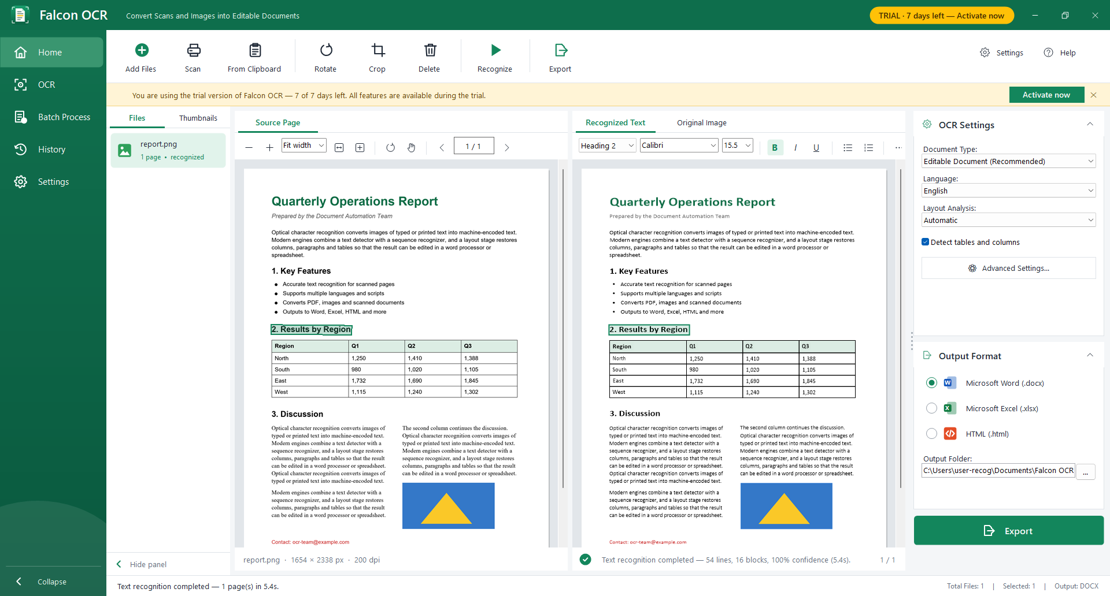
Figure 9 – The selected line is highlighted in the original and in the result

9.1 Side-by-side view
- The Recognized Text tab shows the page rebuilt from the recognized text at the same positions as the original: fonts, sizes, bold text, colors, tables and pictures.
- Zoom and scrolling are linked: zoom with −/+, the zoom box (Fit width, Fit page, 50–300 %), Ctrl+mouse wheel; move with the scroll bars, the mouse wheel, the hand tool or the middle mouse button.
- Page through with ‹ › or PgUp / PgDn.

9.2 Finding and correcting text
- Click a line in either view — it is highlighted in both, so you can compare it with the original.
- Characters the recognizer was unsure about are highlighted in yellow.
- Double-click the line (or press F2 / Enter) and correct the text. Press Enter to keep the change or Esc to cancel. Corrected lines are underlined with a dashed blue line and exported as corrected.

9.3 Changing formatting
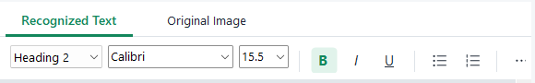
Figure 10 – Formatting toolbar: style, font and size boxes, B / I / U, lists
- With a line selected, use the style box to make its paragraph Normal, Heading 1–3 or a list item.
- The font box and the size box show the font of the selected line. Choose another font or size from the list, or type a font name or a size (e.g. 10.5) and press Enter — the whole paragraph changes and the export uses the new font.
- B, I, U switch bold, italic and underline for the paragraph.
- The list buttons turn the paragraph into a bulleted or numbered list item.
- ⋯ menu: switch the yellow highlighting on or off, copy the text of the page or of the whole document.

9.4 Original Image view
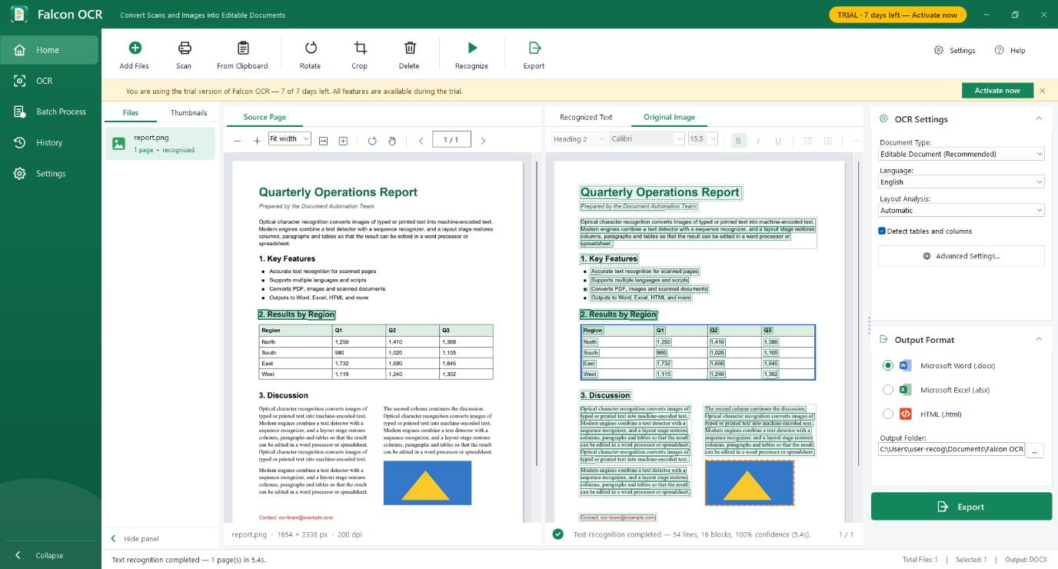
Figure 11 – Original Image: detected text lines (green), table (blue), picture (orange)
The Original Image tab shows what Falcon OCR found: text lines in green, tables in blue and pictures in orange. Use it to understand the result — for example, if a table was not detected.

10. Exporting
- Choose the output format and the document type on the right.
- Click Export (or Ctrl+E). If some pages are not recognized yet, Falcon OCR offers to recognize them first.
- The file is saved in the output folder with the document's name (a number is added if the name exists, e.g. report (2).docx) and opens automatically. Use Export as… in the Files context menu to choose name and folder yourself.

10.1 What the exports look like
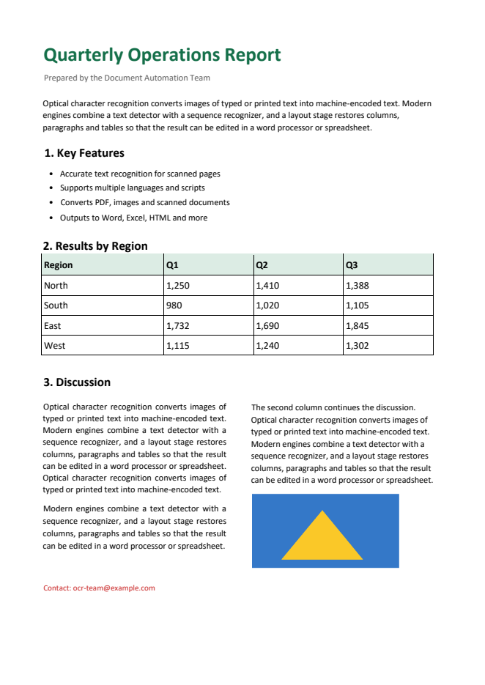  Figure 12 – Word — Editable Document | 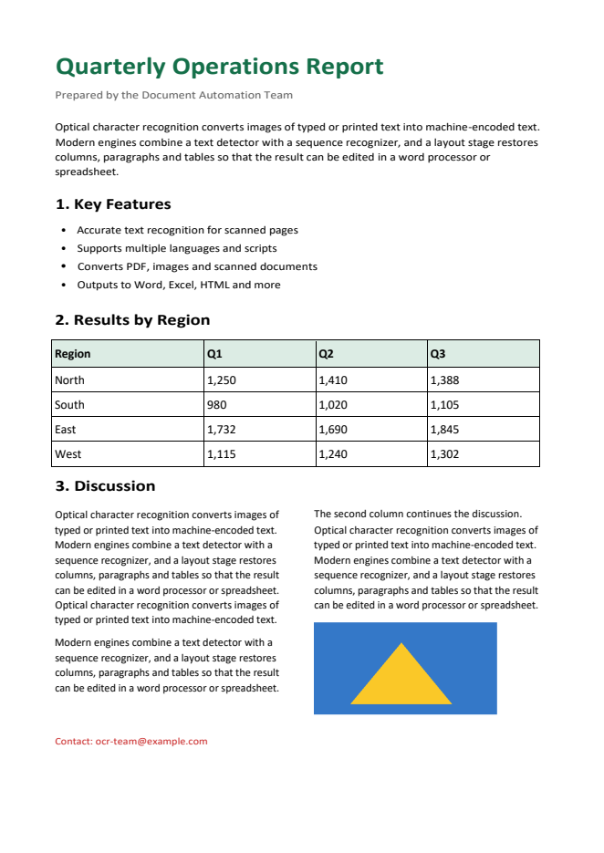  Figure 13 – Word — Exact Copy
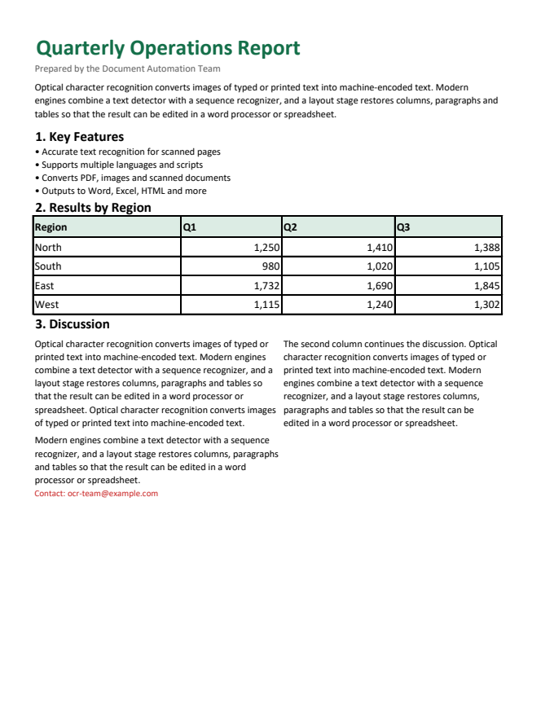  Figure 14 – Excel — tables as real cells | 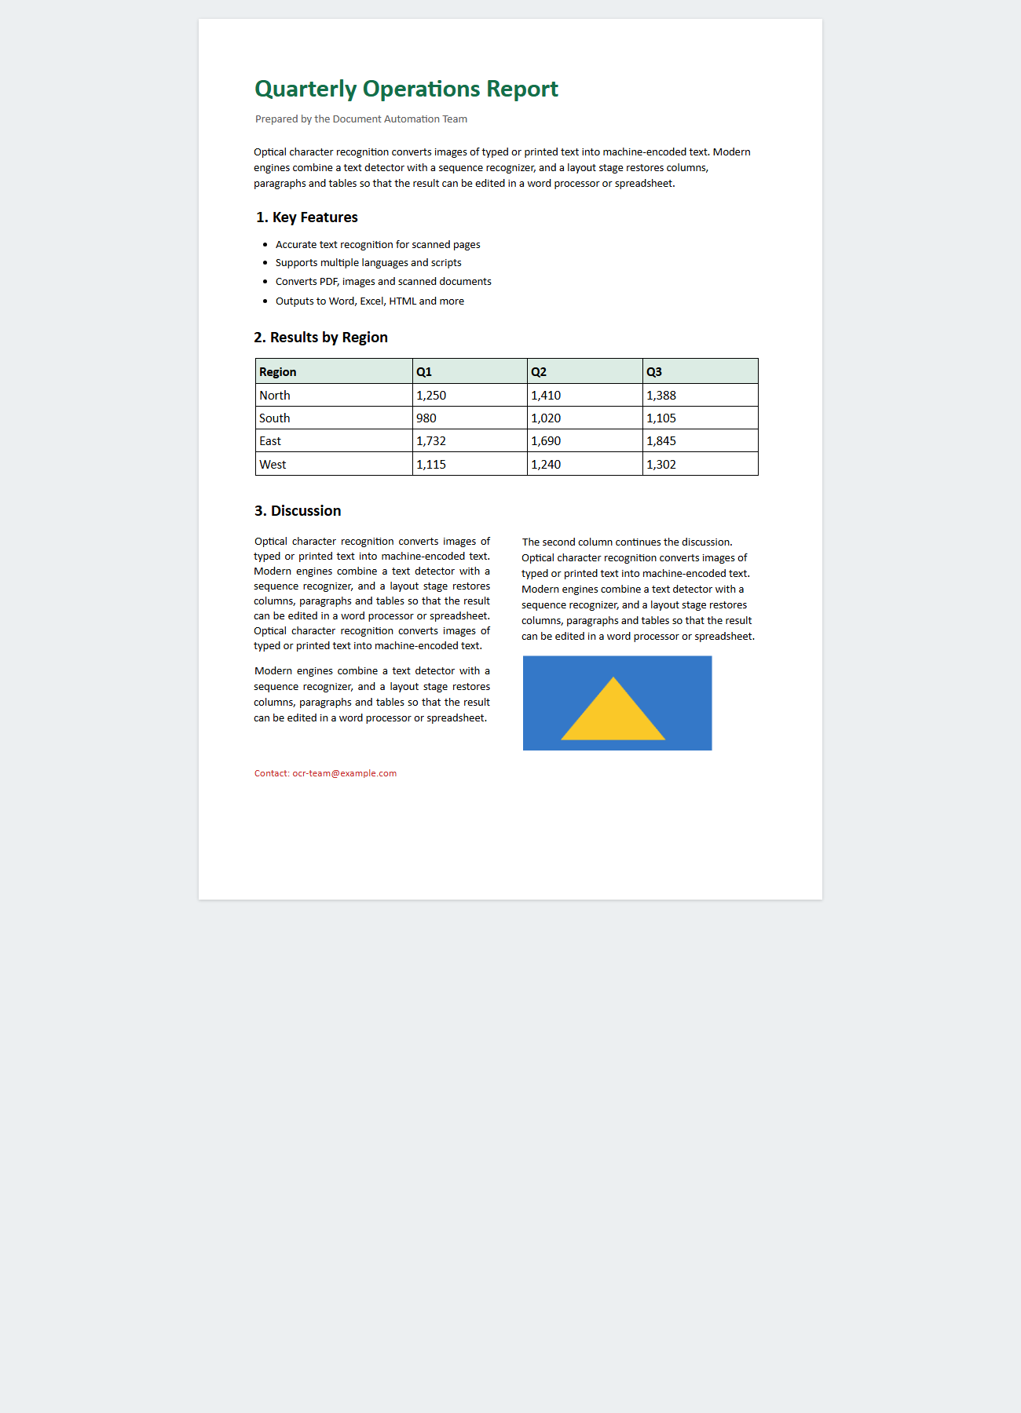  Figure 15 – HTML — web page
Table 7 – Choosing a format
Format | Best for | Details
Word — Editable | Letters, reports, articles, books | Text flows and can be edited; headings use Word heading styles (useful for a table of contents); columns, lists, tables and pictures are kept.
Word — Exact Copy | Forms, flyers, complex layouts | Looks like the original; each line is a separate text frame, so larger edits are less comfortable.
Excel | Tables, invoices, statements | One worksheet per page; tables become real cells (merged cells, borders, fills); numbers can be calculated.
HTML | Publishing, archives, e-mail | One self-contained file with the pictures inside; opens in any browser.

11. Quick OCR
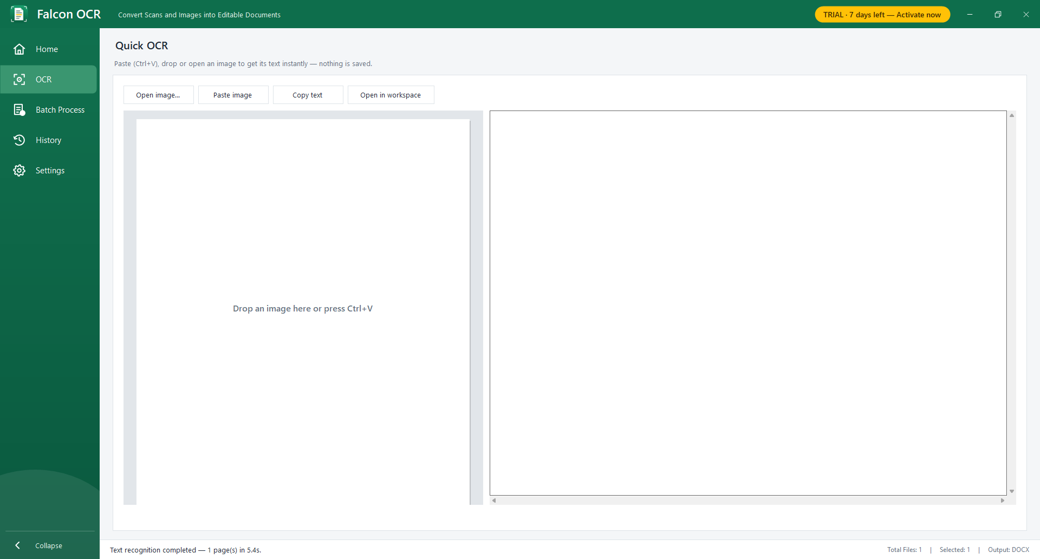
Figure 16 – Quick OCR
Use OCR in the navigation bar when you just need the text of an image — for example a screenshot. Press Ctrl+V (or Paste image), drop an image, or click Open image…. The text appears on the right; click Copy text. Open in workspace moves the file to Home for a full conversion. Nothing is saved.

12. Batch processing
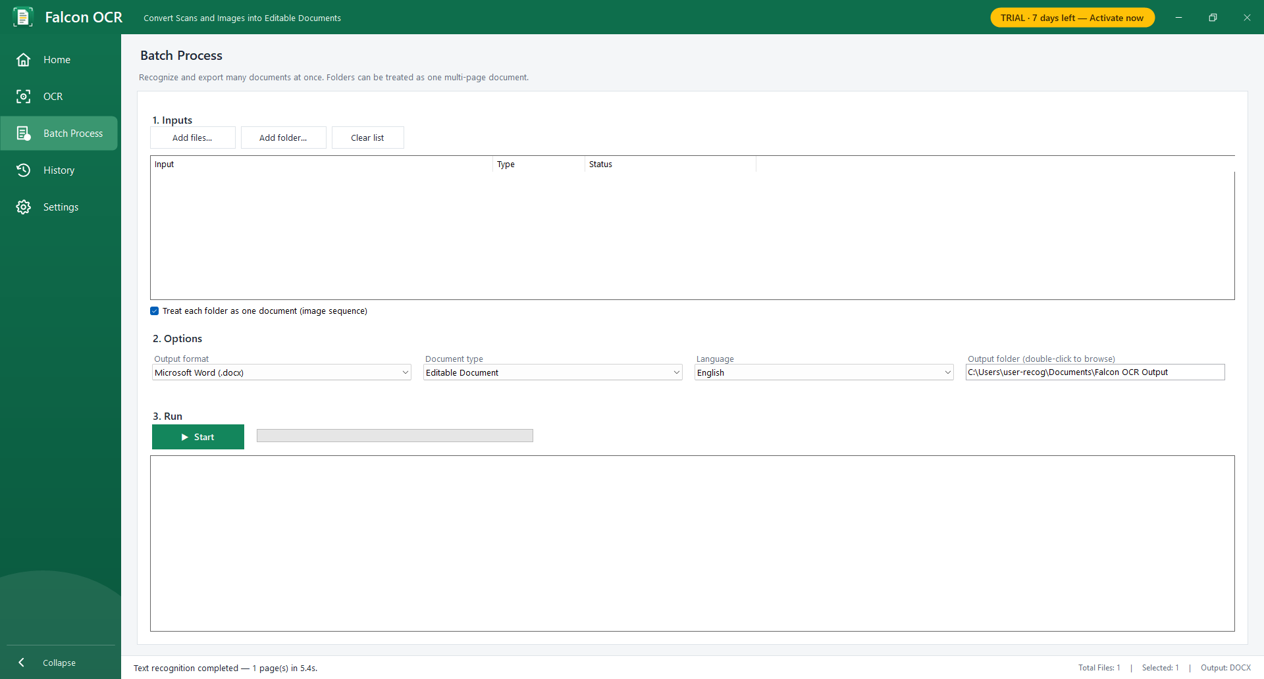
Figure 17 – Batch Process
- Open Batch Process.
- Click Add files… or Add folder… (or drag files and folders into the list). With Treat each folder as one document a folder of images becomes one multi-page document.
- Choose output format, document type, language and output folder (double-click the folder box to browse).
- Click Start. Each entry shows its progress; the log lists every result. Click Stop to cancel after the current page.
- At the end, Falcon OCR offers to open the output folder.

13. History
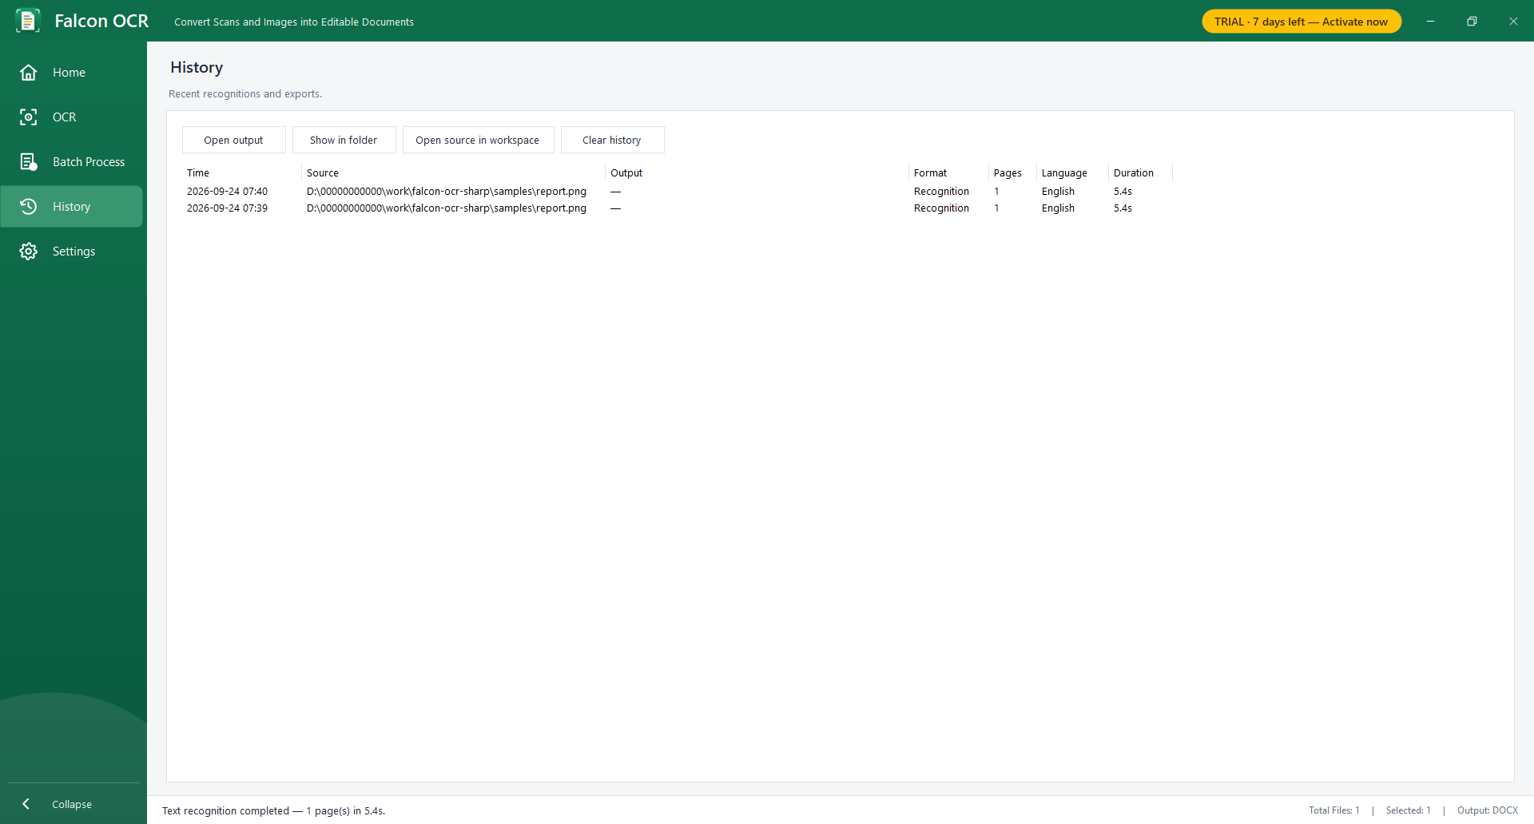
Figure 18 – History
History lists your recognitions and exports with time, source, output file, format, pages, language and duration. Select an entry and click Open output (or double-click), Show in folder or Open source in workspace. Clear history removes all entries.

14. Settings
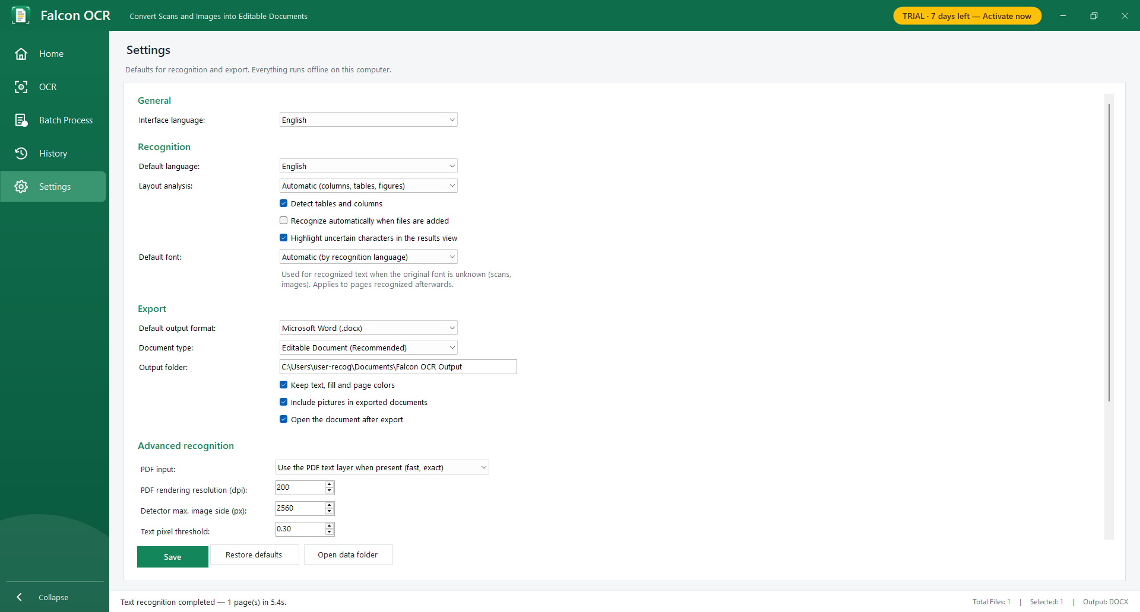
Figure 19 – Settings
Table 8 – Settings
Section | What you can set
General | Interface language (English, 简体中文, 日本語) — takes effect after a restart.
Recognition | Default language and layout analysis, table detection, recognize automatically when files are added, highlight uncertain characters, default font (Automatic uses the usual font of the recognition language; choose a font to use it for scanned text whose font is unknown — it applies to pages recognized afterwards and to exports).
Export | Default output format (also Plain text), document type, output folder, keep colors, include pictures, open the document after export.
Advanced recognition | The options of chapter 7.3.
License | License or trial status, your machine code, Change license key…
Click Save to apply. Restore defaults resets all values; Open data folder opens the folder with your settings and history.

15. Command line
falcon-ocr.exe (in the same folder) converts files without opening the window — useful for scripts and scheduled tasks. It uses the same license or trial as the application.
falcon-ocr <files or folders> [-l en|zh|ja|ko|ru] [-f docx,xlsx,html,txt] [-o output-folder]
[--exact | --plain] [--seq] [--no-tables] [--ocr-only] [--dpi 300] [--cls] [--font NAME]
falcon-ocr --license <key> activate
falcon-ocr --machine-code show the machine code
Examples:
falcon-ocr invoice.pdf -f xlsx -o D:\Out
falcon-ocr D:\Scans\Book --seq -l ru -f docx
falcon-ocr C:\Inbox -f docx,html --exact
Table 9 – Command-line options
Option | Meaning
-l | Language (default en).
-f | One or more formats, comma separated (default docx).
-o | Output folder (default: next to the source).
--exact / --plain | Exact Copy / Plain Text instead of Editable Document.
--seq | All inputs form one image-sequence document.
--no-tables | Do not detect tables.
--ocr-only | Ignore PDF text layers.
--dpi | PDF rendering resolution.
--cls | Correct upside-down lines.
--font NAME | Default font for text whose original font is unknown.
Exit codes: 0 = success, 1 = usage error, 2 = models missing, 3 = not activated / trial ended.

16. Keyboard shortcuts
Table 10 – Keyboard shortcuts
Keys | Action
Ctrl+O | Add files
Ctrl+V | Paste image or files from the clipboard
F5 | Recognize the current document
Ctrl+E | Export
Ctrl+R | Rotate page
Del | Remove document (Thumbnails: page)
PgUp / PgDn | Previous / next page
Ctrl+Plus / Ctrl+Minus, Ctrl+wheel | Zoom in / out
Middle mouse button (drag) | Pan the page
F2 or Enter | Edit the selected line
Enter / Esc (while editing) | Keep / cancel the change
Esc (crop mode) | Cancel cropping

17. Tips for best results
- Scan at 300 dpi (200 dpi minimum) in color or grayscale. Avoid very dark or blurry scans.
- Photograph pages straight from above in good light; crop away the background before recognizing.
- Select the correct language — it makes the biggest difference for non-Latin scripts.
- Rotate pages that are sideways before recognizing.
- For digital PDFs keep Use the PDF text layer — the text is then exact.
- Use Exact Copy for forms and flyers, Editable Document for everything you want to edit.
- Check yellow-highlighted characters first; they are the most likely errors.

18. Troubleshooting
Table 11 – Troubleshooting
Problem | Solution
'Some OCR model files are missing' | The application folder is incomplete. Copy the complete Falcon OCR folder again.
'Falcon OCR must run as a 64-bit process' | Use a 64-bit Windows.
The text is wrong or empty | Check the language setting; for scans use at least 200 dpi; rotate sideways pages; lower the text thresholds in Advanced Settings.
Text of a two-column page is mixed | Make sure Layout Analysis is Automatic; if a single-column page is split, choose Single column.
A table is not recognized | Tables with visible lines work best. Check the Original Image tab. For tables without lines try Exact Copy or Excel.
Headings are recognized as normal text | Select the line and choose Heading 1–3 in the style box before exporting.
A picture contains text I need | Switch off 'Keep pictures and graphics as images' in Advanced Settings.
A digital PDF gives strange characters | Advanced Settings → PDF input → Always run OCR.
Export does not open | Install Word/Excel or a compatible program, or switch off 'Open the document after export' and open the file from the output folder.
'No scanner was found' | Connect the scanner and install its WIA driver; or scan with the scanner software and add the files.
The application closes after the start window | The trial has ended and no key was entered — see chapter 3.
An unexpected error message | Details are written to %LOCALAPPDATA%\FalconOCR\error.log — send this file to your support contact.

19. Privacy and data
Falcon OCR processes everything on your computer and does not connect to the internet. It stores only the following in %LOCALAPPDATA%\FalconOCR: settings.json (your settings), history.json (recognition and export history), license.key (your license), trial information, scans (pages acquired from a scanner) and error.log.

Appendix A. Glossary
Table 12 – Glossary
Term | Meaning
OCR | Optical character recognition: reading text from images.
Document | One entry in the Files list — a PDF, an image, a multi-page TIFF or an image sequence.
Page | One page of a document.
Image sequence | Several image files combined into one multi-page document.
Text layer | Text stored inside a digital PDF.
Editable Document | Export with flowing, editable text and the rebuilt structure.
Exact Copy | Export that places everything at its original position.
Machine code | Code that identifies your computer for a computer-bound license.
License key | Text starting with FOCR- that activates Falcon OCR.

